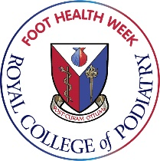
Short CPD Reflections
Foot Health Week Activities

Participating in Foot Health Week can count towards your CPD requirement for the Health and Care Professions Council. Creating information for the public, speaking with colleagues, carrying out information events and creating foot health social media content can all contribute to your annual requirement.

To help you document this for your audit trail, you can use the outlines below to capture your activity and reflections on your participation.
To learn more about the HCPC standards on CPD, visit the HCPC website at https://www.hcpc-uk.org/cpd/

Name:

Date of Activity:

What activity has prompted your reflections?
Think about the activities undertaken and any questions raised by you as result

What are your key learning points?
Think about how these are relevant to your practice

What does this mean for your development and your clinical practice?
Think about how you can apply your learning to your practice and what effect it will have on you and those around you.

What actions will you take as a result of this reflection?
Think about the areas of further learning you may need to do or actions in your practice that you would like to implement as a result of this reflection. If you create a list of action points, set a target date and a think about when you should review these.

